She’s 11-Years Old - Great Rise Ball?

by Gerald Warner, Softball Pitching Instructor


It’s a great dream…a young pitcher throwing the infamous rise ball. Pitchers and their parents like to brag about their repertoire of pitches…even though all of the pitches often look alike with no movement at all. A rise ball is not merely a pitch that is released low and thrown to a chin-high spot. Other pages on this site discuss the spin direction, fast spin speed, and fast pitch speed required for a “legitimate” rise ball. In 20 years of training scores of pitchers of all ages and observing thousands more we are yet to see a pre-teen pitcher with a true “moving” rise ball.
Many young pitchers have been misled…and some even hurt…by consistently trying to throw a
riser before they are capable of doing it. It doesn’t work for a young pitcher…and here is why:
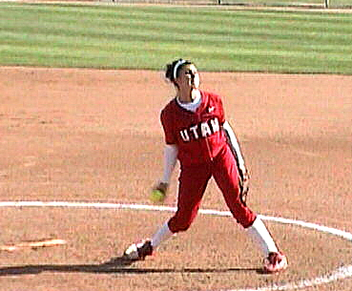
A sizeable percentage of pitchers, even older experienced ones, do not even know the direction that a rise (or even a drop ball, curve, or screw ball) needs to spin in order to cut into the air to make the ball go in a specific direction. And a rise ball, in order to really move, needs to be spinning bottom-to-top at almost twice the speed of a drop ball. And even with good spin, for a rise ball to work right it needs to be thrown at a speed at least in the mid-50’s…and preferably 60+ mph. Former Olympian and ESPN softball announcer Michele Smith feels that the best speed for a good rise ball is between 61 and 65 mph.
Classic form for a rise ball release
We have seen many team coaches of 10U, 12U, and even some 14U teams, thinking that a pitcher has a rise ball simply because she throws high pitches, calls for the rise pitch to be thrown during games. And then, when the pitch simply comes in as a high flat fast ball, blames the pitcher every time an opposing batter connects with it. Good rise ball pitchers often place their rise ball at mid-thigh on the batter…provided it has good rise ball spin, spin speed, pitch speed, and movement.

And to add to the problem, many people who give pitching lessons try to teach a rise ball release to young pitchers without disclosing the very small potential of success (and the real risk of injury when practicing the hard wrist snap) . By attempting to teach the rise ball to a young girl, it (1) gives false hope to the pitcher, (2) has her and her parents “thinking” that she can throw a rise ball, but (3) keeps the pitcher going back to the instructor for more lessons. Most responsible pitching instructors will wait until a pitcher is ready…in terms of ability, pitch speed, and commitment…before having her to start working on a rise ball. For some, that might be at 14 or 15-years old…others much later.

See also these pages on the PitchSoftball.com website:

http://pitchsoftball.com/RiseBallSecrets.html

http://pitchsoftball.com/Page11.html

http://pitchsoftball.com/AllPitchesHaveanArc.html

If you have questions or need more information
E-mail us at: gw@pitchsoftball.com or call Pitching Instructor Gerald Warner in Denver at (720) 200-4575

