Does a Rise Ball Really Rise?
How a Rise Ball Works

by Gerald Warner, Softball Pitching Instructor


There has long been differing opinions between fastpitch softball players vs. die-hard students of physics and aerodynamics as to whether a properly thrown rise ball can overcome the gravitational force trying to pull it toward the ground, enough to really RISE.

The author of this article, Gerald Warner, is a longtime softball addict who didn’t gain much from his Physical Science minor in college…so he has had to gain this information during the past several years from people who are a lot wiser. Our thanks to Jaclyn Parlo and Armstrong Atlantic University’s Physics Department, Gustav Magnus, Angie Triplett and The College of Wooster Physics Department, and many others.

As we have mentioned in other articles on this website, the majority of young pitchers who have been told or “think” they can throw a rise ball do NOT:
- Release the ball with correct backspin (top-to-bottom as seen by the catcher)
- Impart fast enough spin speed (at least 23 to 25 revolutions per second)
- Pitch the ball fast enough (mid-50’s at a minimum)
…so MOST pitchers are not yet able to throw a truly effective rise ball.
More information of some of the correct techniques for throwing a rise ball can be found on this website at:
Rise Ball Secrets

Although most of us pitching instructors, pitchers, hitters, coaches, and parents feel that we have seen rise balls “hop” over the top of a bat, there is no scientific evidence to prove that a softball can be thrown with sufficient speed and backspin to make an upward arc in its trajectory. Many of us have flicked a table tennis ball to make it dramatically curve, drop, and even rise. However, it has been estimated that a 6.8 ounce softball would have to be thrown at over 90 mph with a spin speed in excess of 35 revolutions per second in order to give the ball even a minor upward arc. So…

A “RISE BALL”, EVEN WHEN THROWN CORRECTLY, DOES NOT RISE…
it simply falls slower than a similar speed fastball that doesn’t have backspin and therefore has a more level plane on its path to the plate.

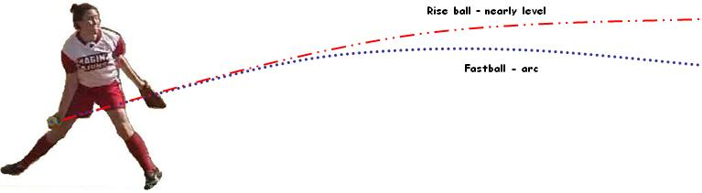

However, because the ball doesn’t have the same gravitational drop as most batters expect, even major league baseball players have been unable to make contact with a well thrown rise ball from a female pitcher.

Does a Rise Ball Really Rise? – page 2

THE MAGNUS EFFECT - Although there are many factors that contribute to the success of any “breaking” pitch, the easiest for most of us to understand is that the spinning seams on the ball “dig into” the air, causing it to move up, down, or sideways more than a ball that is thrown without the same spin. The principle known as the Magnus Effect (or Magnus Force) lowers the air pressure on one side of a spinning softball, creating low pressure (essentially a slight vacuum), and causing the ball to either move in a specific direction or, in the case of a rise ball, remain in the air for a longer distance and therefore not dropping as much in the trip from the pitcher’s hand to the batter.

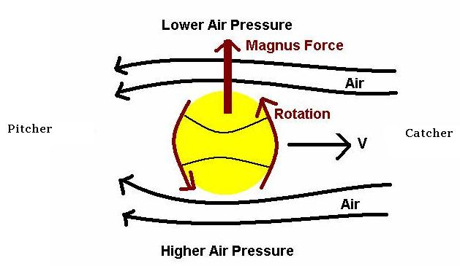

If you have questions or need more information
Call Pitching Instructor Gerald Warner in Denver at (720) 200-4575 or e-mail me at: gw@pitchsoftball.com

