Screw Ball…the “Intimidator”

by Gerald Warner, Softball Pitching Instructor

Although it is not a “go to” pitch, the screwball is an excellent
weapon for a softball pitcher to have in her repertoire of pitches.
The screw ball hooks in the opposite direction of a pitcher’s curve ball, which means for a right handed pitcher, it curves to the right (obviously, for a lefty a screw curves to the left). Typically, the screw is thrown to a same-sided batter up and on the inside corner…tight against the batter’s hands. On occasion, depending on the situation and the batter, it is thrown down and in. For an opposite-side batter (a right-handed pitcher throwing to a left-handed batter, or a lefty throwing to a right-handed batter), the screw ball can be used as a “chase” pitch…low and away.

The keys to throwing a good screwball are the same as for other breaking pitches:
- It must spin the correct direction
- It must spin rapidly
- It must be thrown with sufficient speed
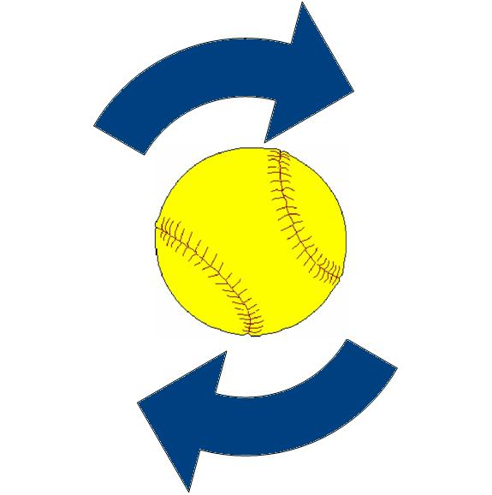
The typical direction of spin for a screwball is side-to-side, …for a right hander that means that the spin will be moving over-the-top to the right.

Here is an example as seen by a right-handed pitcher as the ball heads toward the plate:

Basic mechanics for throwing a screwball:

GRIP: As with most breaking pitches, the grip on the ball can vary from one pitcher to another. However, many like to place the pads of the fingers on the stitches at the top, or end, of the “horseshoe” (or “U”). Another option is for the 2nd and 3rd fingers to be placed on the “narrows”…where the stitches come closest together.

STRIDE: Many pitchers are more effective by using a “side step” when throwing a screwball, meaning that a right hander will step well to the left of the power line. The length of the stride should be essentially the same as for a fastball.

ARM SWING: We strongly recommend that our pitchers use an “arc” motion instead of following a straight line with the final portion of their arm swing:
- As the arm starts its final downswing toward the release, it is away from the body
- Nearing the release it closes in to the body…think of it is the inside of the forearm brushing against your abdomen.
- Then the arm continues back out with the “arc” motion at the release of the ball.

TIGHT SNAP AT THE RELEASE: The key to imparting a fast spin on the ball is to twist it quickly as it is being release. The twist is inside-out, meaning that a right hander twists the ball as shown in the diagram above.
As mentioned previously, the screwball is usually not a “go to” pitch. Typically, it is thrown 10% to 15% of the time, depending on the situation, batter’s aggressiveness and proximity to the plate, pitcher’s ability, and the objective with this batter.

If you have questions or need more information, E-mail us at: gw@pitchsoftball.com or call us in Colorado at (720) 200-4575

