“Finishing” the Pitch…for Speed and Control
Develop a Long and Fast Stride, Good Landing, and Correct Pushback Against the Stride Leg

by Gerald Warner, Softball Pitching Instructor


“Stay Tall” and “have a firm front side” - We always encourage pitchers to finish their pitching rotation by bringing their shoulders back and having their body upright (no bending at the waist).

But it is the LOWER portion of a pitcher’s body that can GREATLY improve the speed and control of her fastest pitch. For traditional leaping-style pitchers (the majority of female pitchers are “leapers”), the whole sequence of lower-body pitching “mechanics” is based on three important stages:
(1) a powerful push-off from the pitching rubber
(2) a strong, fast, and long stride
(3) a push-back against the stride leg as the pitching arm
comes down through the release point

The smaller percentage that we call “stepping style” pitchers who use a shorter stride with no leap, depend largely on upper body strength, and their specific mechanics for increasing pitch speed are considerably different from what is being discussed here.

Sir Isaac Newton’s 3rd Law of Motion says that “for every action there is an equal and opposite reaction”. With a “leaping” method of softball pitching, at the end of the stride the push-back against the stride leg serves as the resistance (or “reaction”) for the action of the arm as it does its final downswing into the release of the pitch.

Therefore, a leaping-style pitcher must have a strong, fast push-off from the pitching rubber in order to drive her stride leg out fast and far. Then the power, speed, and landing of the stride determines how effectively the pitcher can push back against her stride leg to give her the resistance for a hard final arm “whip” to throw the ball with maximum speed:

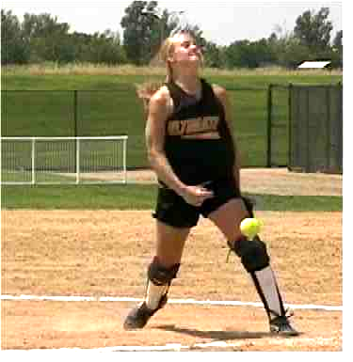

Increase Your Speed with a Good Landing and Correct Pushback (continued)

A good landing of the stride leg is with the knee slightly bent to “cushion” the leg as the pitcher’s weight is temporarily shifted forward. But then, just as in batting, the pitcher “blocks” or “builds a wall” with the stride leg, and pushes back against it. Often, especially with young pitchers, the stride leg is slightly bent at landing, but then bends even more which substantially reduces the pushback against the leg, and virtually eliminates the possibility of throwing a good, fast pitch:
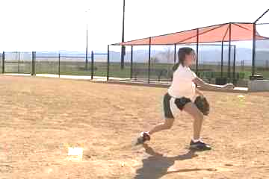
Bent leg…weaker pushback Good pushback…faster pitch

Even though the length of the stride is important (usually 90% to 125% of the pitcher’s height), to work on increasing a pitcher’s speed, we always look at the power and quickness of the stride to allow for a “blocking” or hard push-back against the stride leg at the end of the pitch sequence. Ideally, we want the pitcher to have these positions as the precise point that the pitch leaves her hand:

- Her stride leg which was slightly bent at landing, has straightened , and is at an angle of 15 to 20 degrees (more for rise ball, less for drop ball)

- She is pushing back against her stride leg

- Her upper body is approximately one-third of the way back from her front foot

- Her shoulders are most of the way closed

- Her hips are halfway (or slightly less than halfway) closed

These photos of pitchers of various ages demonstrate all five of these critical components:

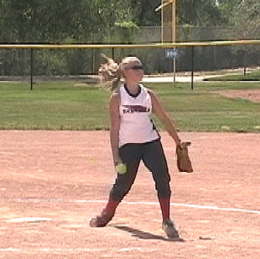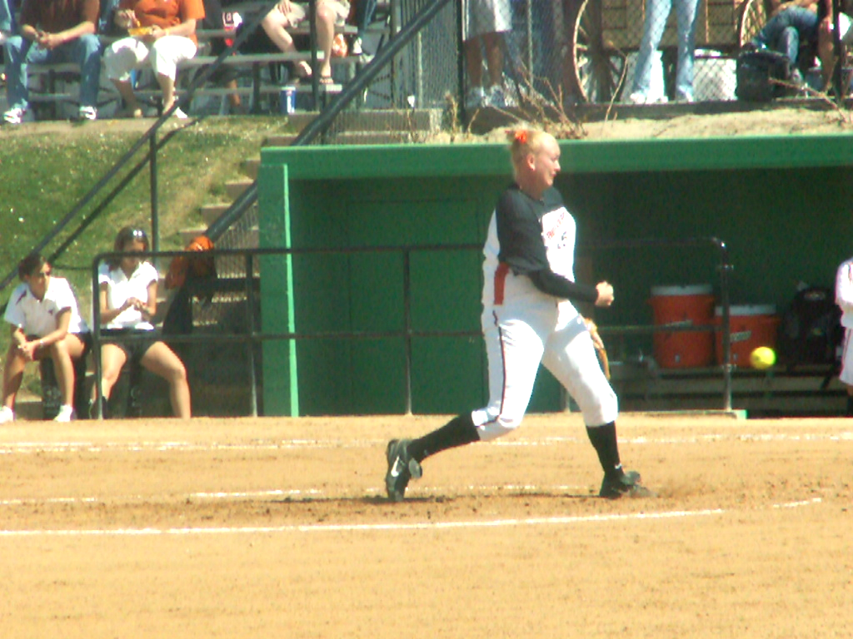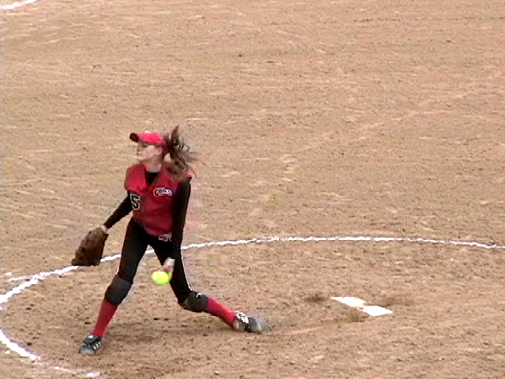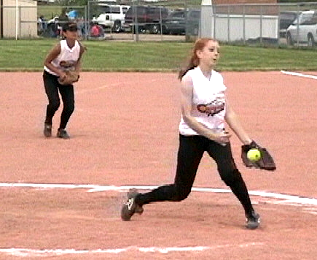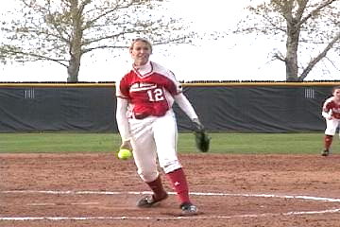

If you want to maximize YOUR pitching speed…and have good control of your pitches, always work on correctly finishing your pitch:

- Upper body upright at the release
- Push back against your stride leg
- Shoulders most of the way closed
- Hips halfway or less closed at the release

If you have questions or need more information
E-mail us at: gw@pitchsoftball.com or call Pitching Instructor Gerald Warner in Denver at (720) 200-4575

