The Fine Art of Creating a Striped Softball

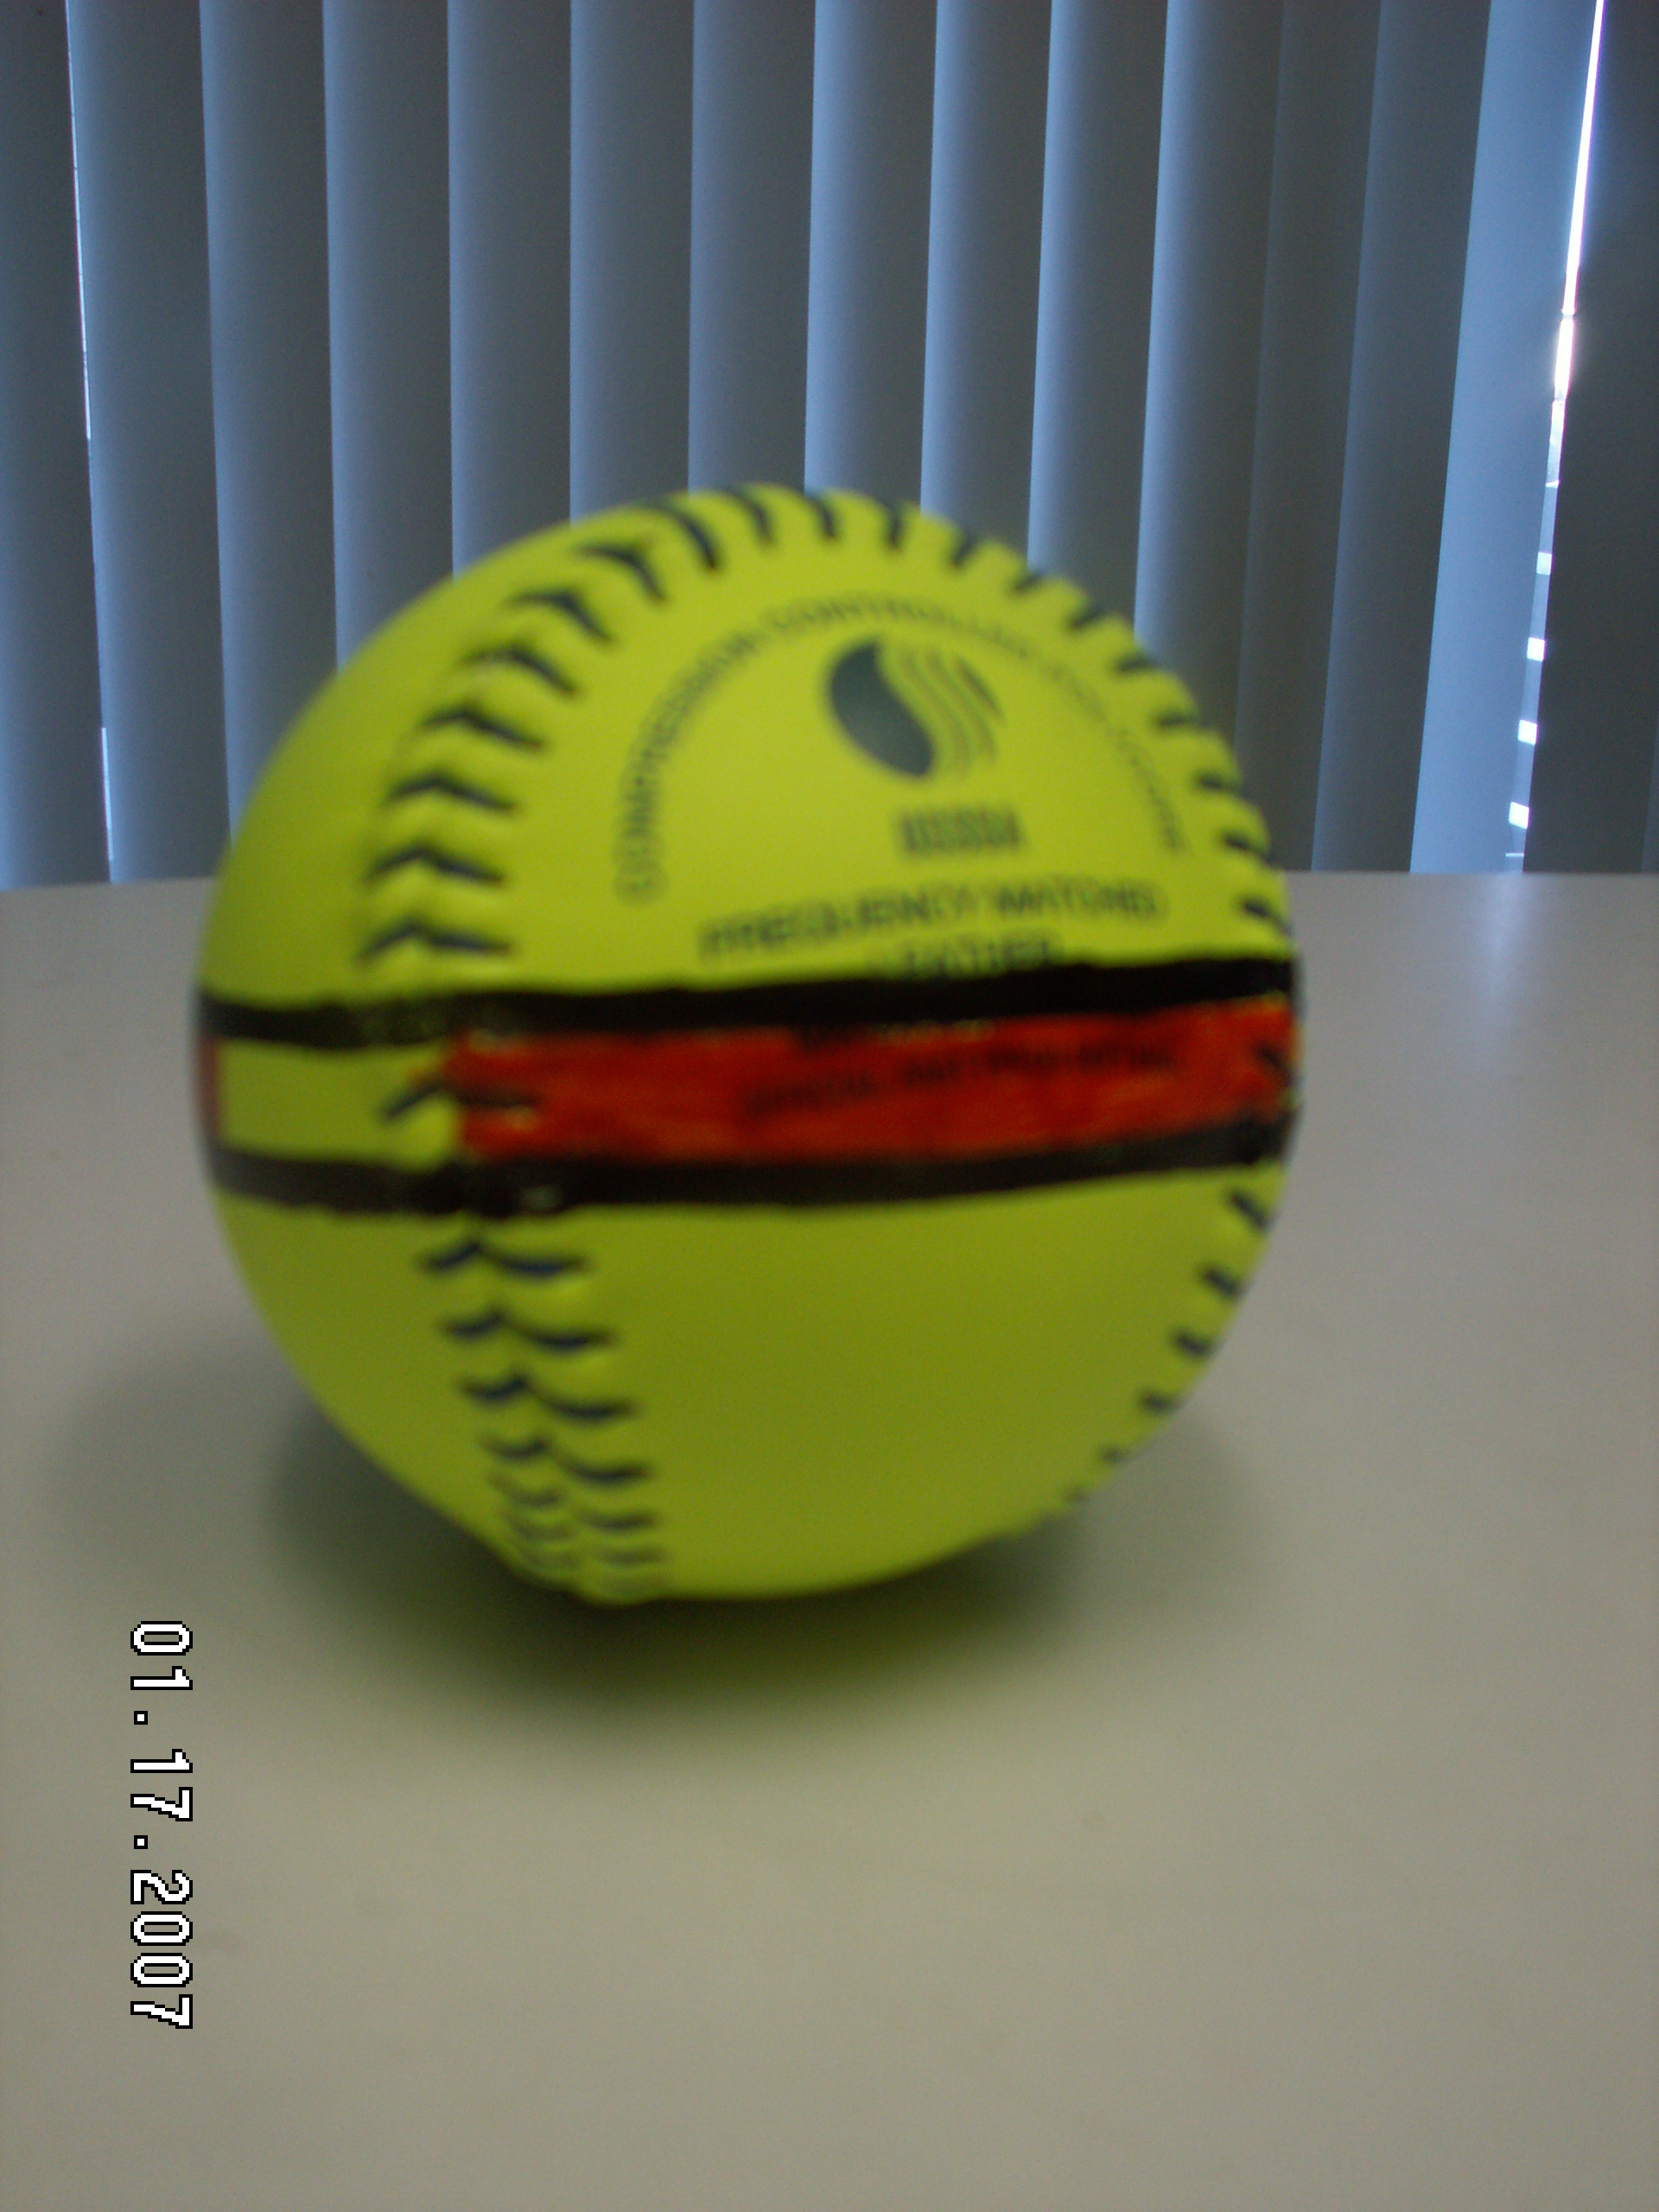
by Gerald Warner, Softball Pitching Instructor

A striped softball is an excellent tool to assist a pitcher with making certain that she has the (a) the correct rotation and (b) the maximum spin speed on her breaking pitches.
If you are highly intelligent, have very good athleticism, and are skilled in freehand art, then you too can create a striped softball. Otherwise, you can get a 12-year old to do it for you.

Seriously though, this is one of the best tools for a pitcher who is constantly trying to improve her drop, curve, screw, and rise balls. Every breaking pitch needs to spin in the correct direction, and needs to be rotating at a fast speed. A ball with a stripe drawn across the center of its four seams is the best visual indicator of spin direction and spin speed.

TO CREATE A (standard “4-seamer”) STRIPED BALL:

(1) Find a cup or glass that is just the right size to allow a softball to sit in the opening, with just a little more than half of the ball sticking above the rim. (Finding the right size cup is kind of fun, because it might involve buying a few different sizes of Slurpees, soft drinks, etc. from your local convenience store or sandwich shop).

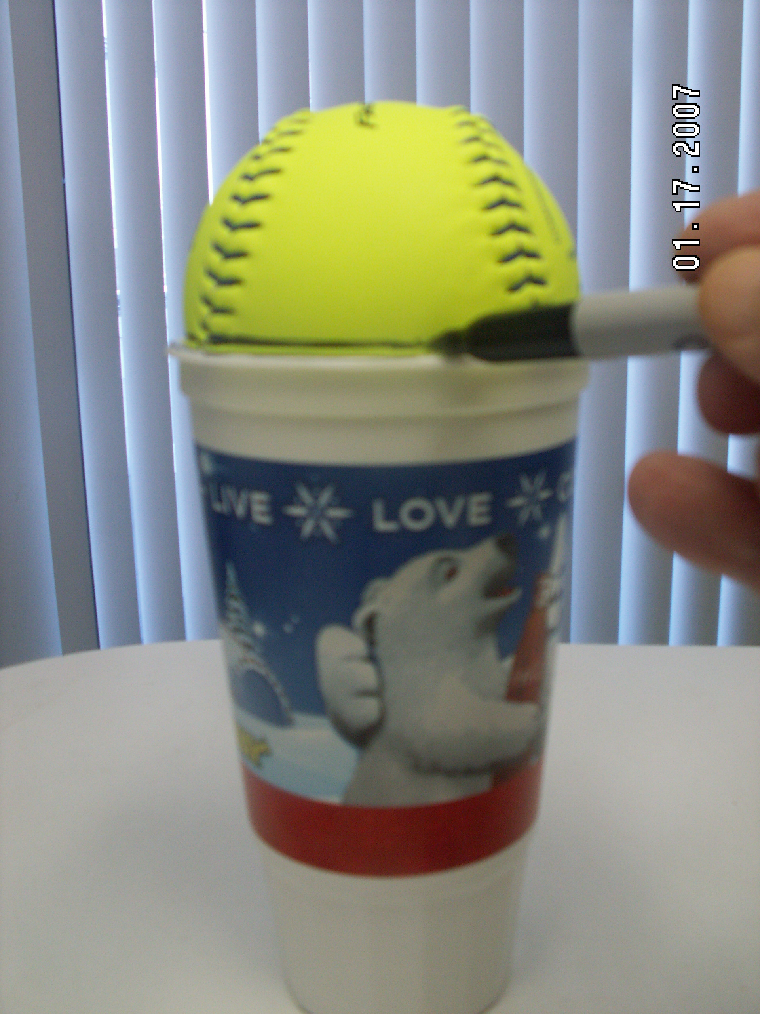
(2) Place the ball softly (don’t push it hard into the cup) into the top with the “narrows” of the seams at the absolute top. Take some time to make certain the ball is correctly set with the middle of the close-together seams straight up.
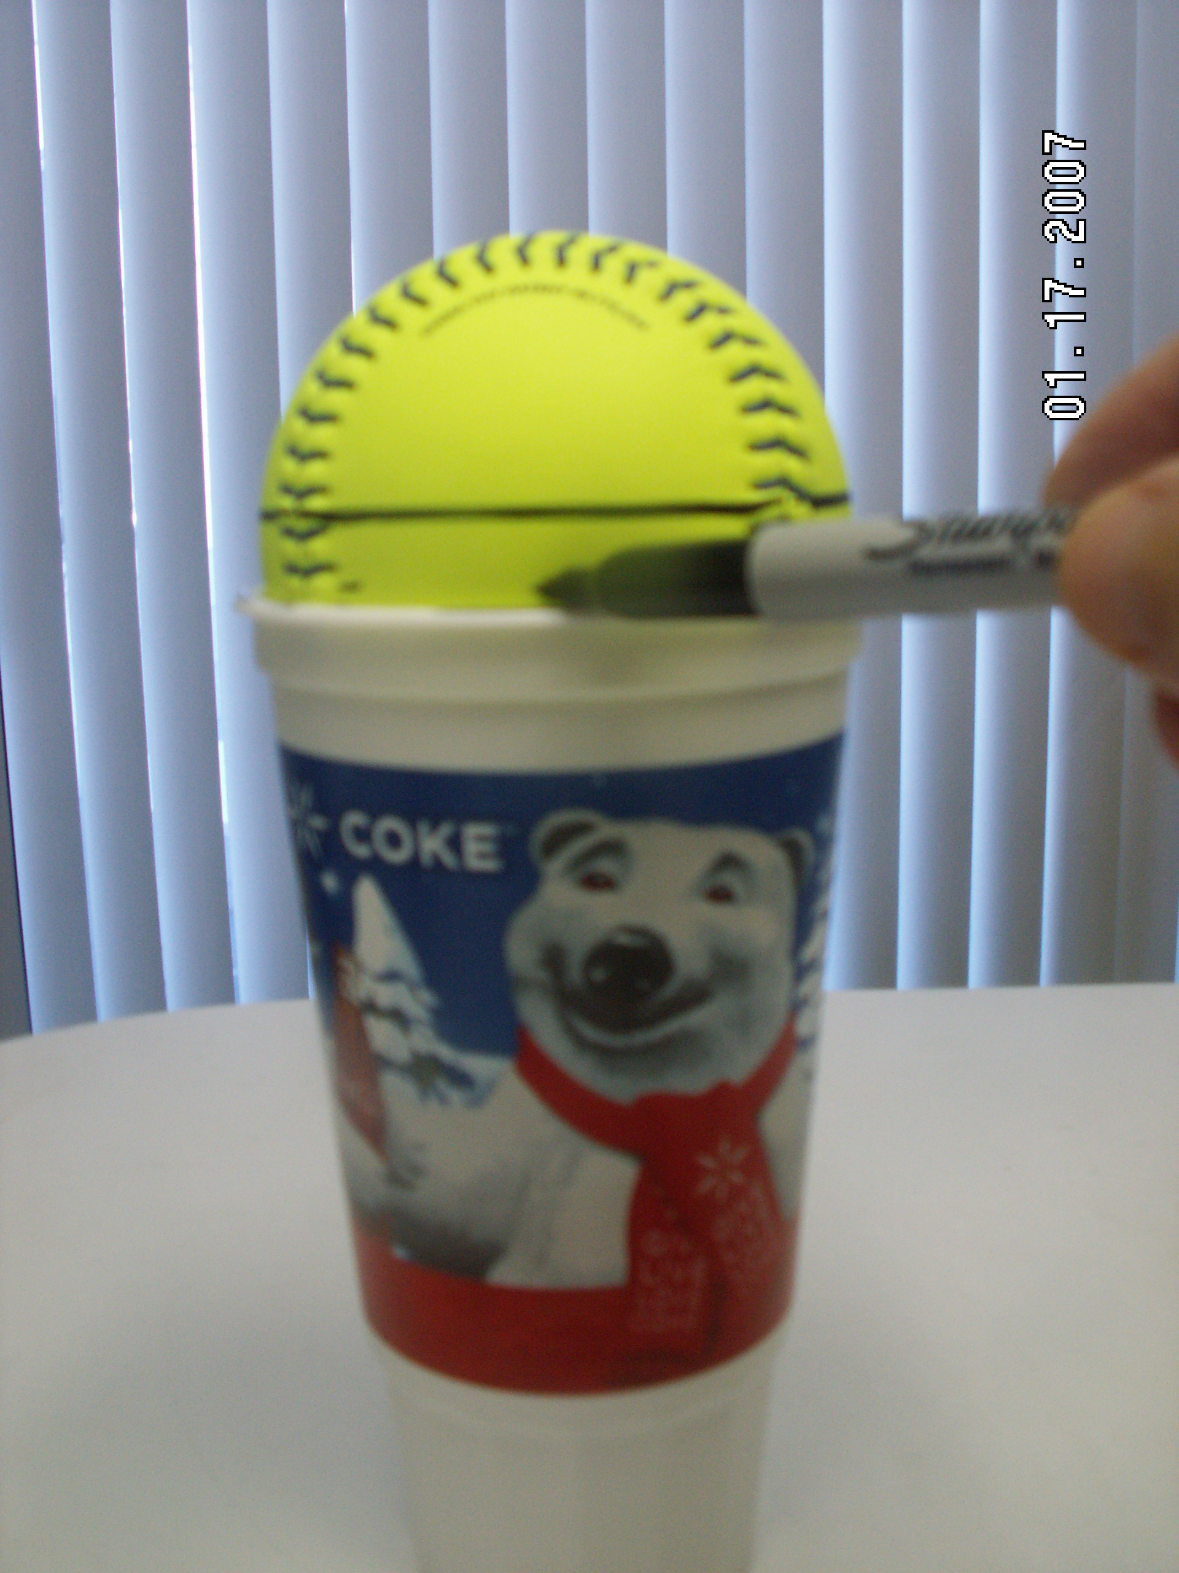
(3) Using the top of the cup as your guide, use a felt-tip permanent marker to draw the first line around the ball… passing through the middle of the 4 wide-apart seams.
(4) After completing the first line, turn the ball over with the other set of “narrows” at the top, and draw the second line the same way.
(5) Leaving some planned open areas, fill in the space between the two lines with another color permanent marker (like the red one in this example). We recommend that you do not fill in the middle areas totally so it will be easier to see the speed of the rotation when the ball is thrown. (See the example at the top of this page).

For pitchers who use a “4-seam” release on each of their breaking pitches, the stripe will make it easy to see the straight or angled direction of the rotation, AND the partially-filled in color will give an indication of the speed of the spin.
If you have questions or need more information, E-mail us at: gw@pitchsoftball.com or call us in Colorado at (720) 200-4575

